Fundamental of Programing

Lab Manual # 05

**Course Instructor:** Dr. Talha

**Lab Instructor:** Muhammad Affan

## Student Name: Haseeb Tahir

## CMS ID: 453901

## Section: C

# Lab Task:

1. **Convert the following while loop to a do-while loop:**

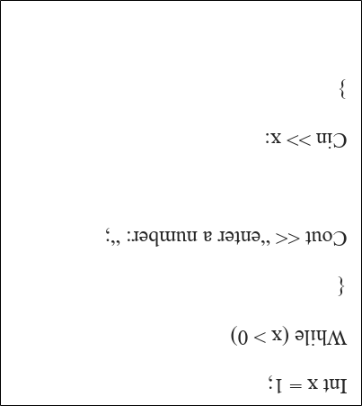

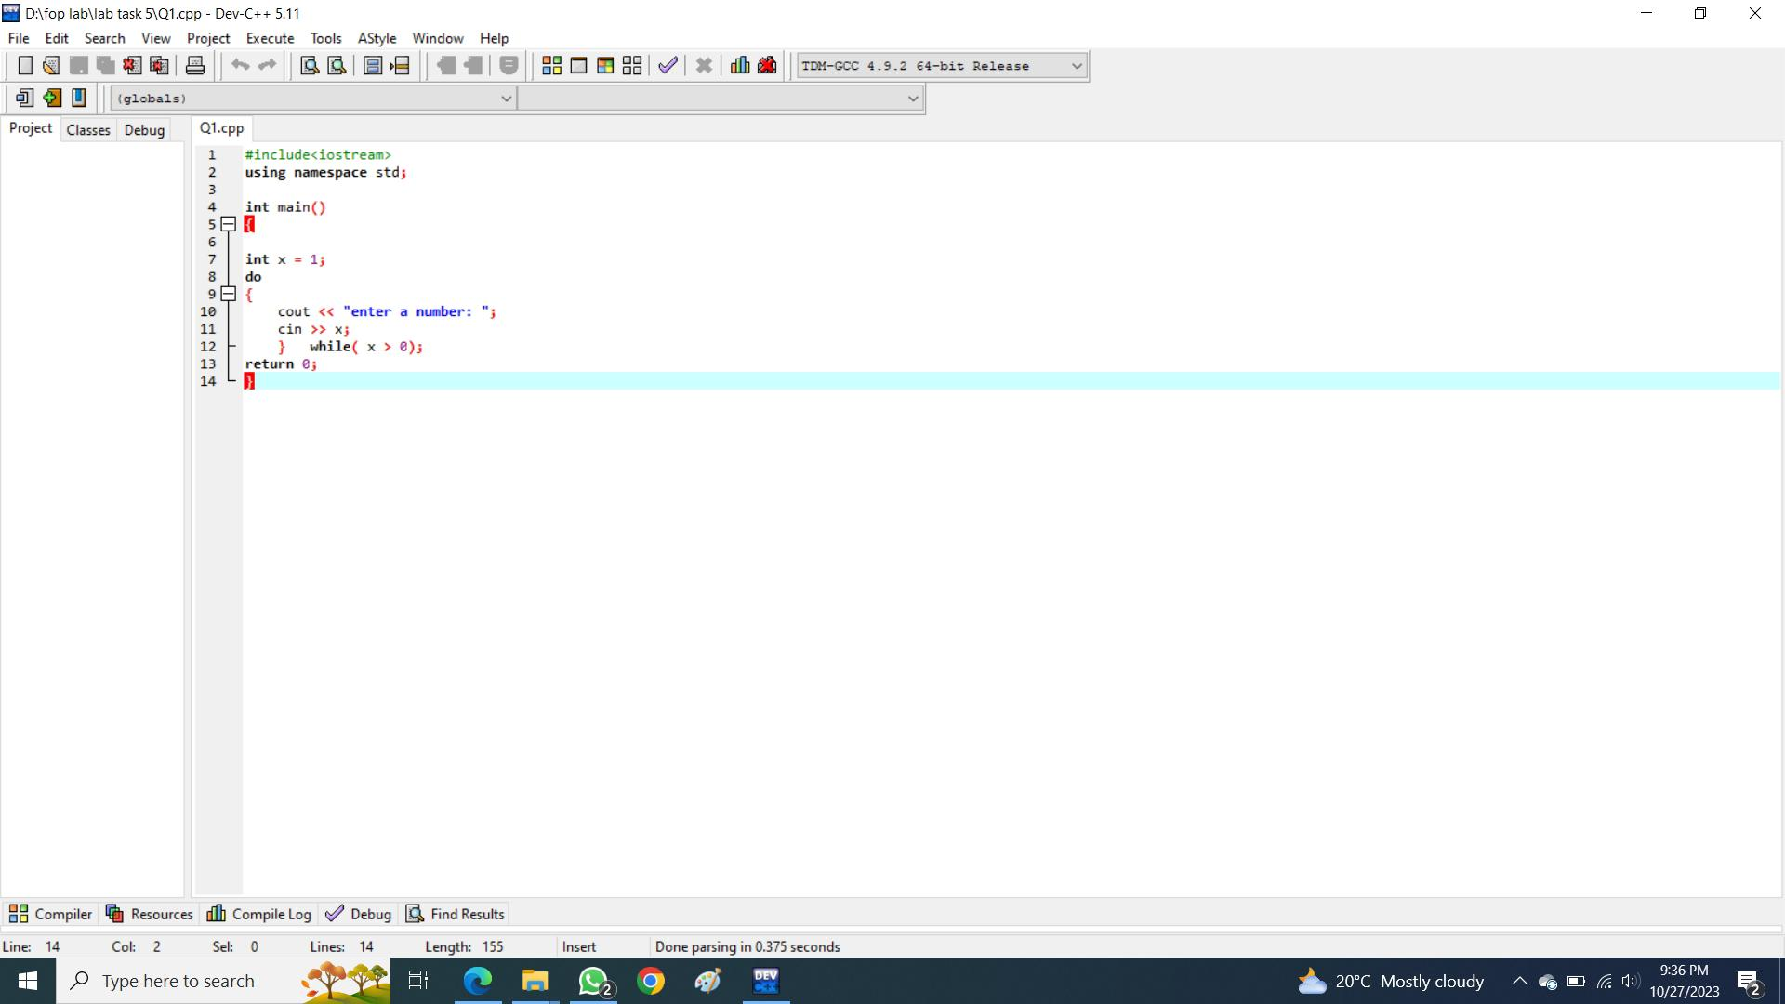

1. **Use a do while loop to make a simple calculator for two numbers. Insert buttons for it to ask again and for termination**

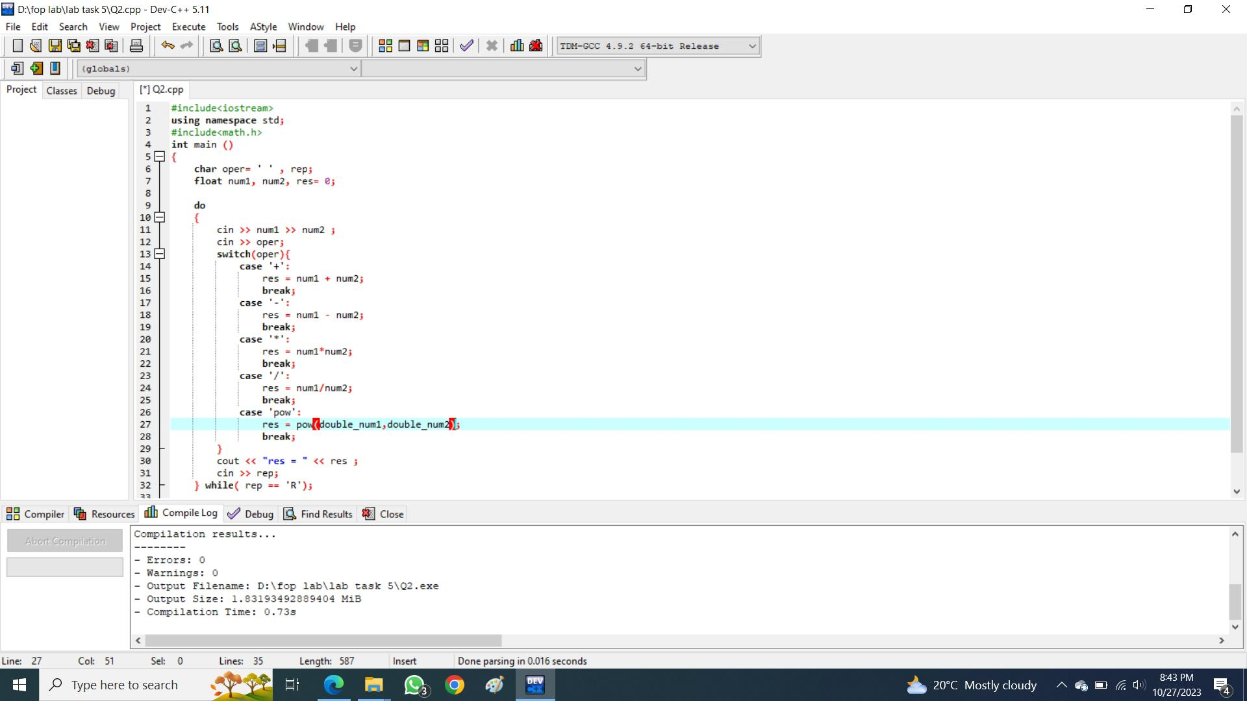

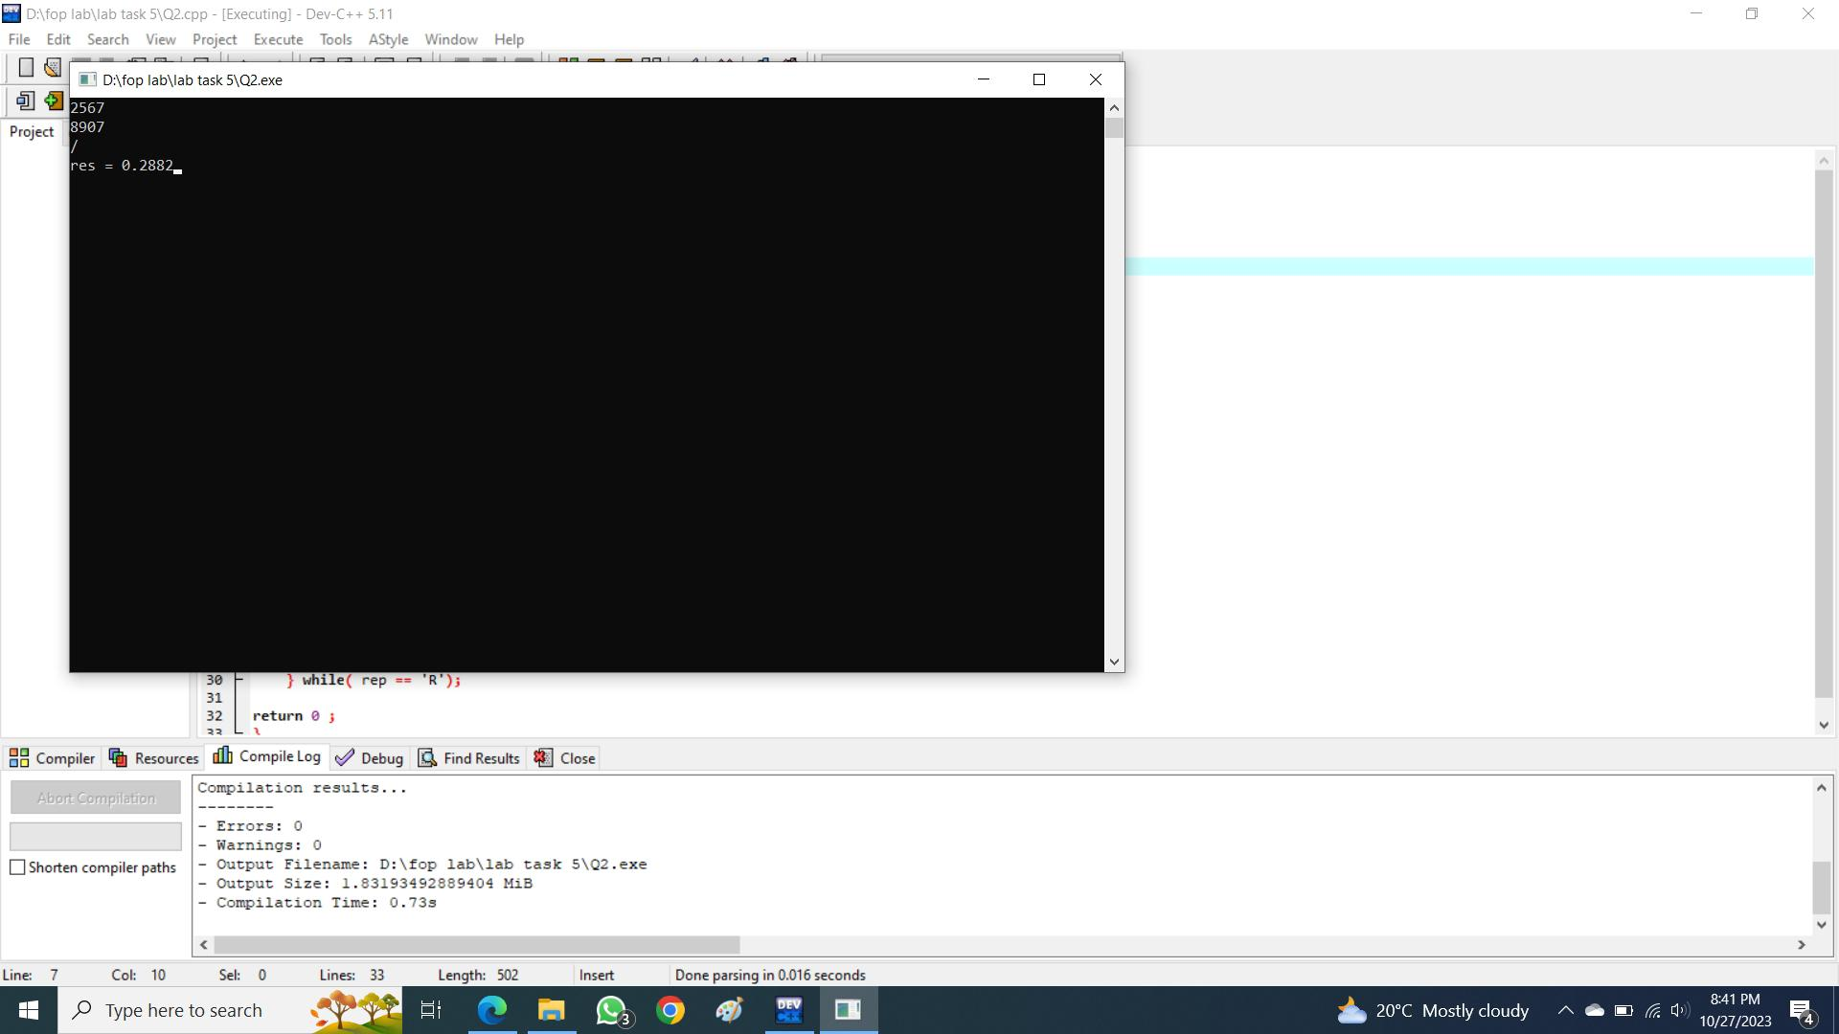

1. **Write programs with while or do while loops that compute:**
2. **The sum of all even numbers between 2 and 100 (inclusive).**
3. 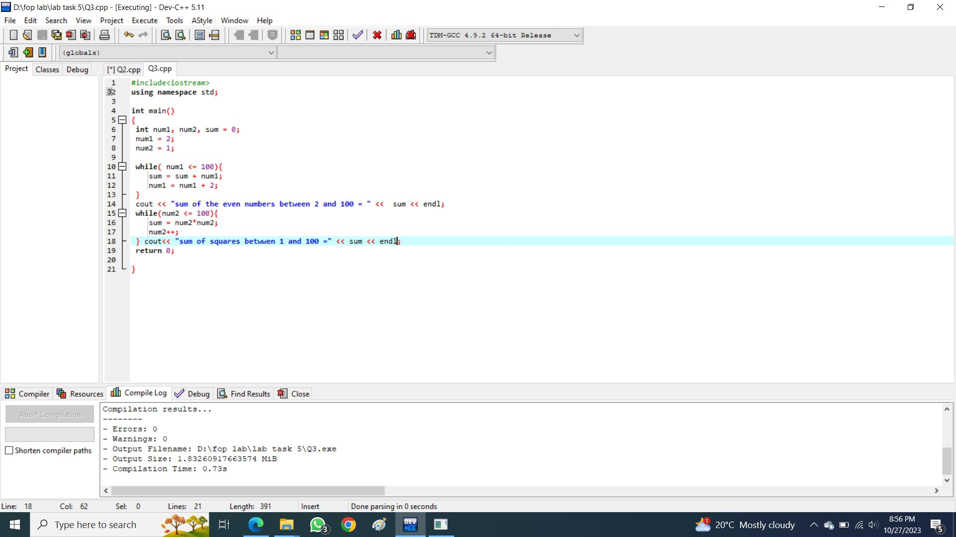**The sum of all squares between 1 and 100 (inclusive).**

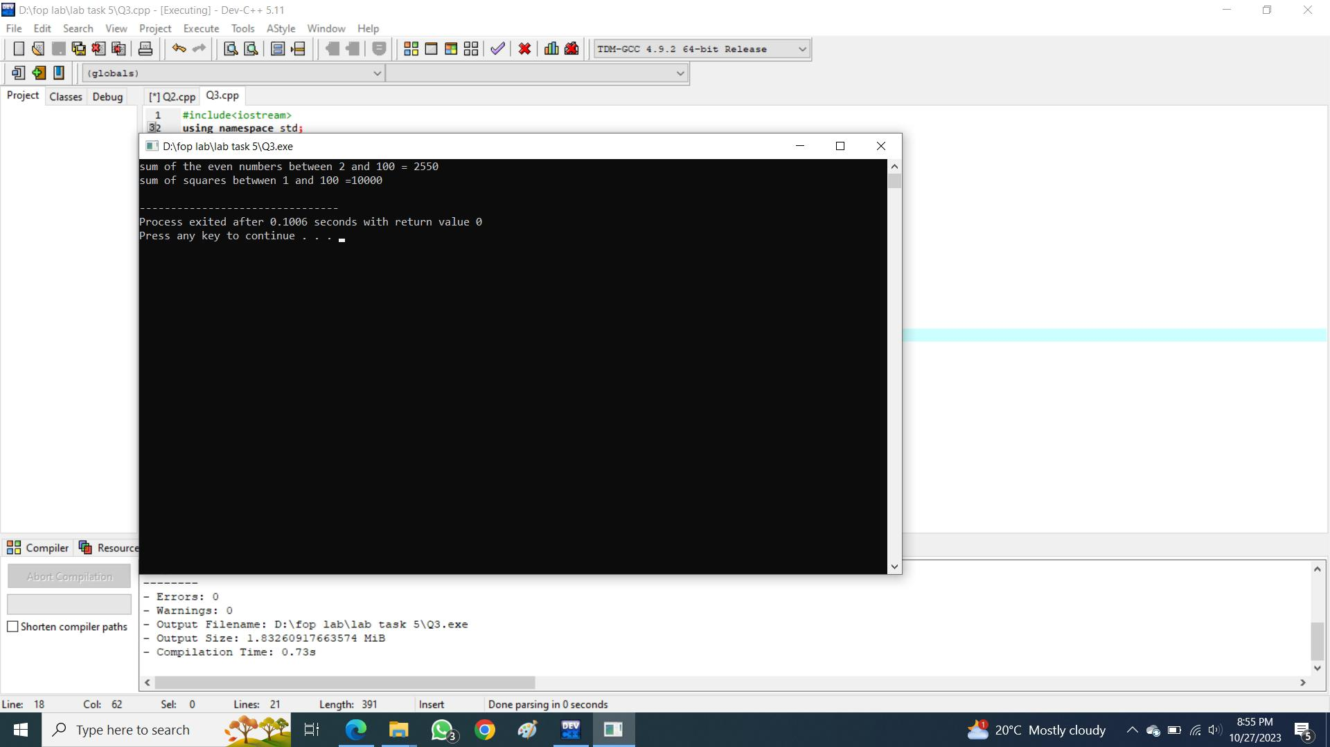

1. **Write programs with while or do while loops that compute:**
2. **All powers of 2 from 2 ^ 0 up to 2 ^ 20**
3. 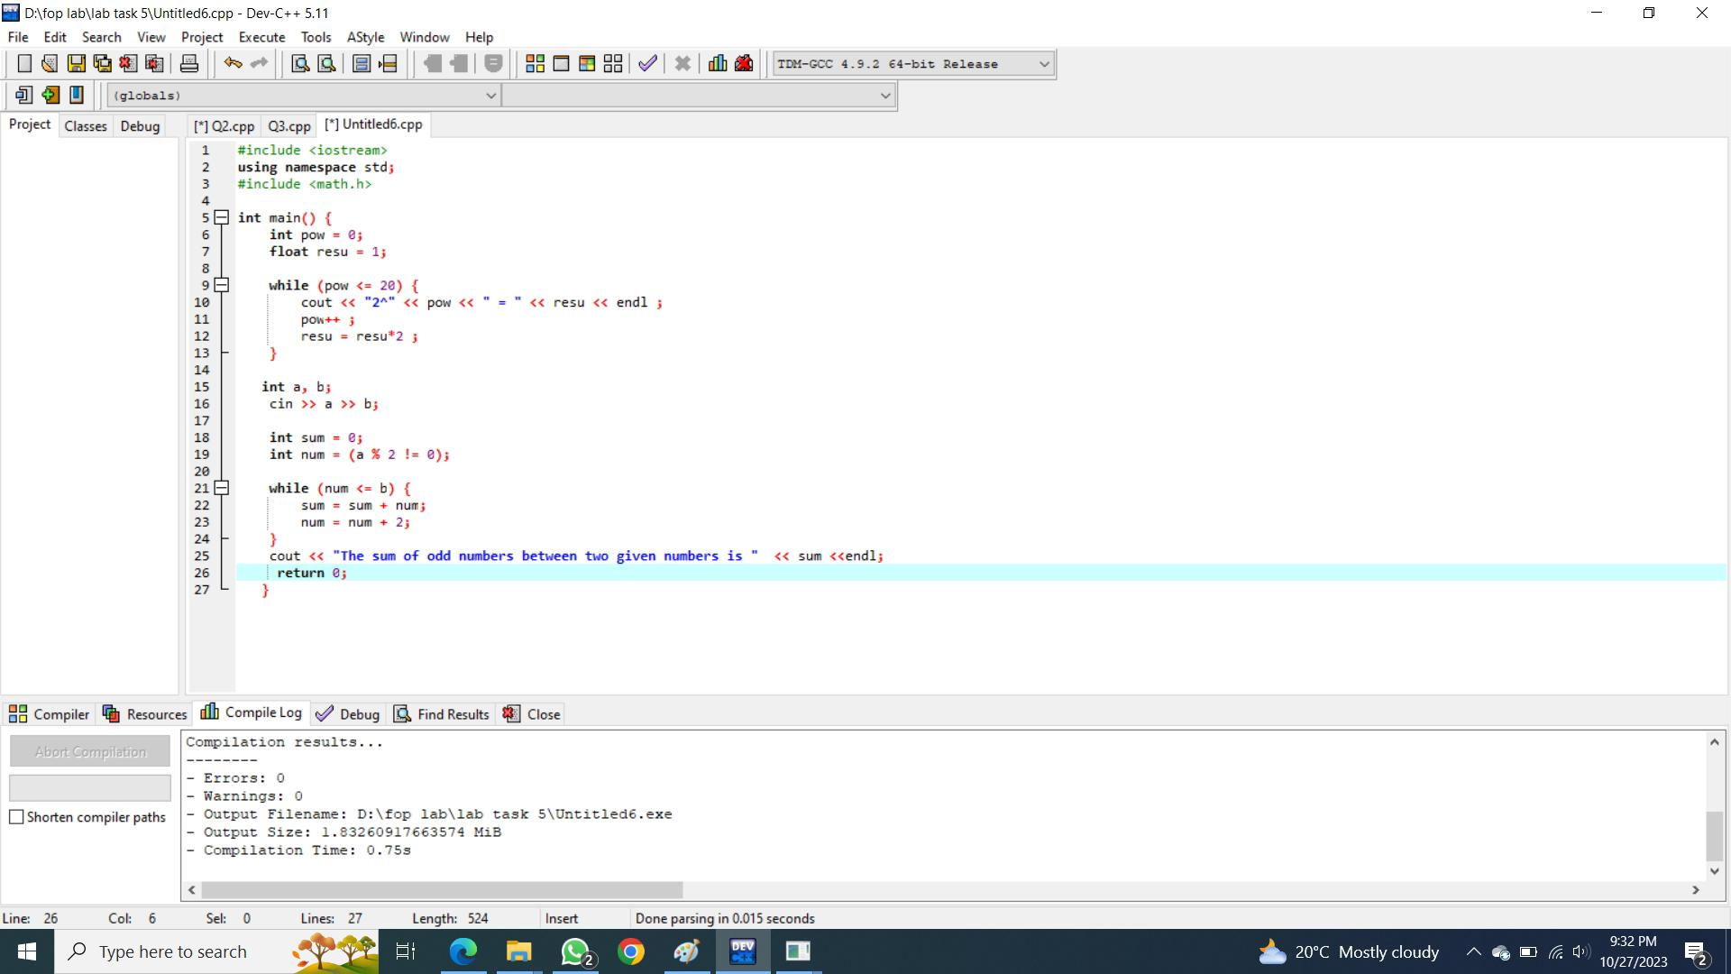**The sum of all odd numbers between a and b (inclusive), where a and b are inputs.**

